KTH Royal Institute of Technology

Lab 2: Support Vector Machines

DD2421 Machine Learning

Yasmin Baba [ybaba@kth.se](mailto:ybaba@kth.se)   
Héloïse Dehem dehem@kth.se

11th October 2019

Move the clusters around and change their sizes to make it easier or harder for the classier to find a decent boundary. Pay attention to when the optimizer (minimize function) is not able to find a solution at all.



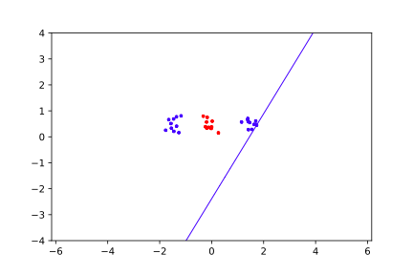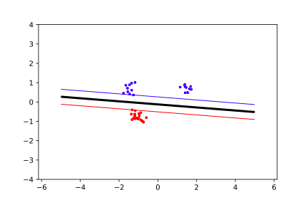

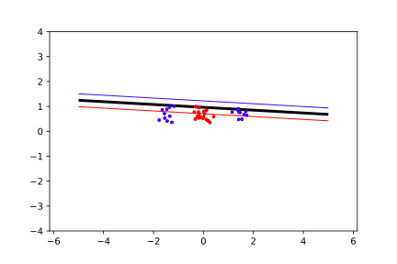

Implement the two non-linear kernels. You should be able to classify very hard data sets with these.

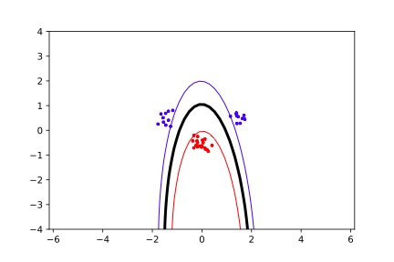**Polynomial  
P = 1 P = 2**

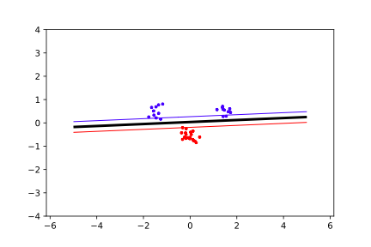

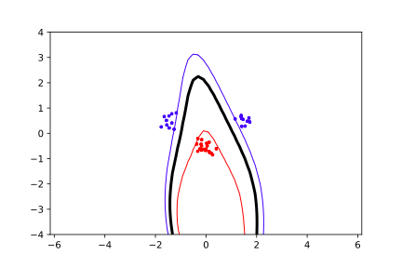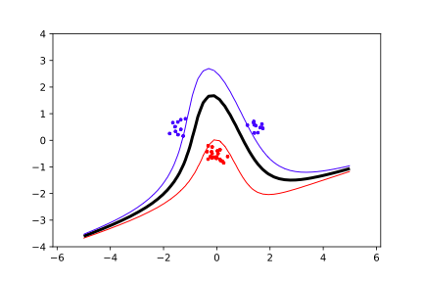**P = 3 P = 4**

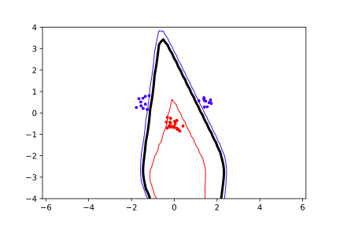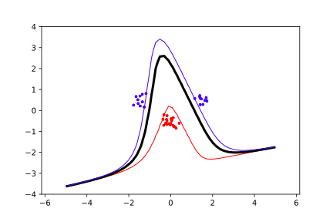**P = 5 P = 10**



**Radial**

$σ=0.2$ $σ=0.5$

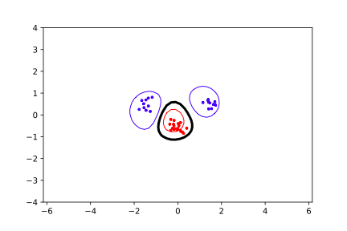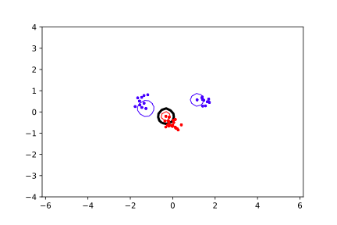

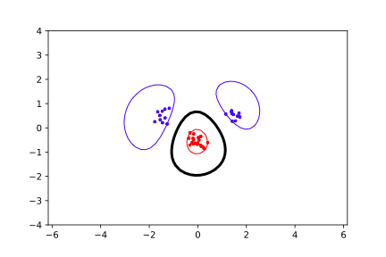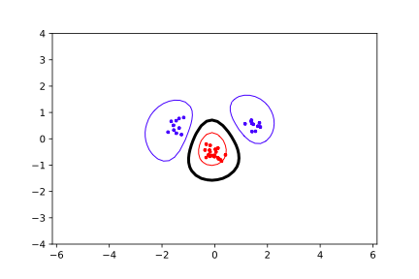

$σ=0.7$ $σ=1$

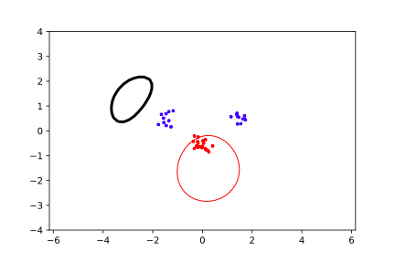

$σ=2$

The non-linear kernels have parameters; explore how they influence the decision boundary. Reason about this in terms of the bias- variance trade-off .

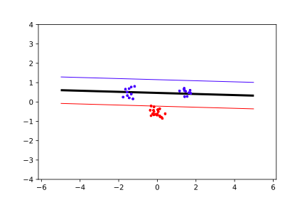**C = 0.1 C = 1**

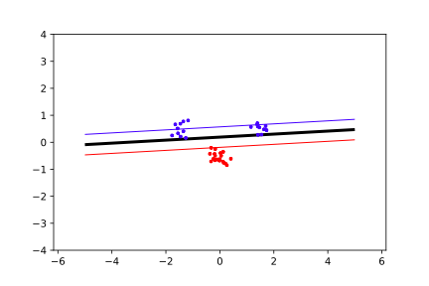

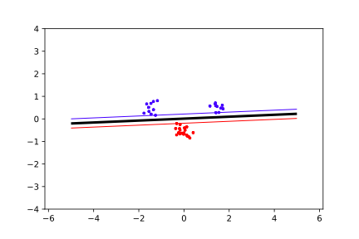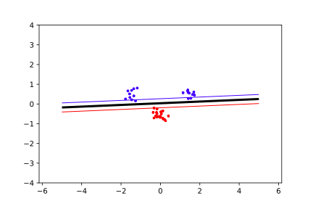**C = 10 C = 1000**